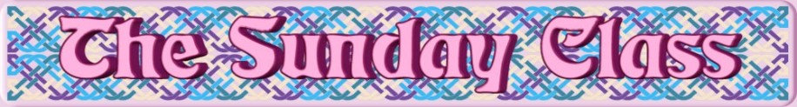

Sunday 13th August 2017 at Eastwell Village Hall
4.30pm - 7.30pm

Five Penny Ness (J5x32)

City of Belfast for 6 couples (S6x32)

Brecon in March (R5x40)

Six Belles of Bon Accord (S6x32)

Interval – Tea and cakes!

Pat George’s Strathspey (S5x32)

The River Ness (R5x32)

Deer Friends (S8x32)

Anniversary Tensome (R5x32)

- - - - - - - - - - - -

www.thesundayclass.org.uk

