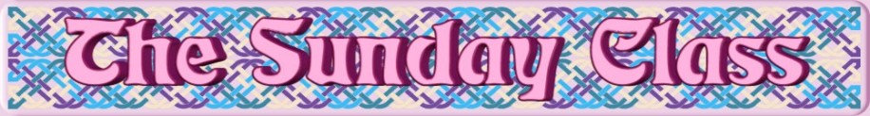

Sunday 22nd October 2017 at Castle Bytham Village Hall
4.30pm - 7.30pm

The Cross-City Line (R8x40)

The Clockwork (S8x32)

Butterfly Bride (R4x48)

Take Wing (J4x32)

Alcanede Strathspey (S4x32)

Interval – Tea and cakes!

Tactful Dancers (A Dance For Elizabeth) (R8x32)

Balance On-line (S4x32)

Stanford Swing (J8x40)

- - - - - - - - - - - -

www.thesundayclass.org.uk

