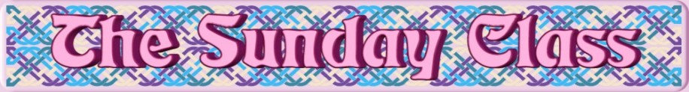

Sunday 30th July 2017 at Castle Bytham Village Hall
4.30pm - 7.30pm

Spaghetti Junction (J8x32)

The City of Birmingham (S4x32)

The Sea Otter & the Pallas Cat (R8x32)

The Orchards of County Armagh (S3x32)

Forward to Frankfurt (R8x40)

Interval – Tea and cakes!

The Half Crown Jig (J4x32)

Appleby Horse Fair (S8x32)

Bauldy Bain’s Fiddle (R8x32)

Mell Square (S2x32) Sq.set

Stanford Swing (J8x40)

- - - - - - - - - - - -

www.thesundayclass.org.uk

