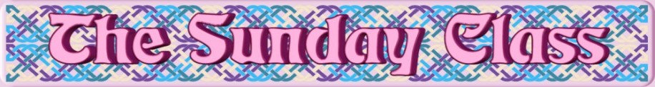

Sunday 18th February 2018 at Castle Bytham Village Hall
4.00pm - 7.00pm

The Bees They Are a’Drummin’ (R8x32)

Born to Dance (J8x32)

Land of the Heather Hills (S4x32)

Pinewoods Reel (R8x32)

Take Wing (J4x32)

Interval – Tea and cakes!

Jenny Freeman’s Strathspey (S6x32)

Campbeltown Loch (J4x48)

The Outer Circle (R8x48)

Zytglogge (R8x32)

- - - - - - - - - - - -

www.thesundayclass.org.uk

