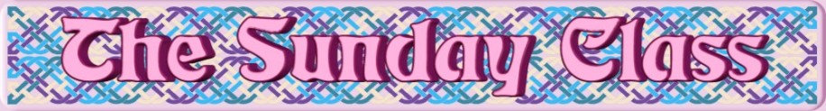

Sunday 28th July 2019 at Castle Bytham Village Hall
4.30pm - 7.30pm

Tae Ane An’ A’ (J8x32)

You Are Not Alone (S3x32)

The Flitting of Lorn (R4x32)

Boudica’s Brooch (S6x32) 2C

The Borrower (R8x32)

Interval – Tea and cakes!

Ballylesson’s Ruby Celebrations (J5x32)

Shepherd Wheel (S3x32)

The Scallywag (J8x40)

Royal George on the Tay (S8x32)

Hungarian Bride (R5x40)

Blooms of Bon Accord (R4x32)

- - - - - - - - - - - -

www.thesundayclass.org.uk

