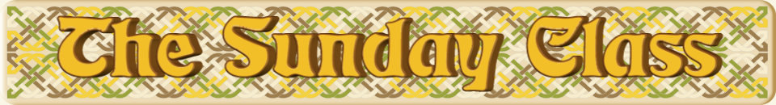

Sunday 8th January 2017 at Eastwell Village Hall
4.00pm - 7.00pm

Castle Varrich (J8x32)

The Golden Chain (S3x32)

The Ginzton Frolic (R3x40)

The Crown of Kings (S1x96)

Interval – Tea and cakes!

A Celtic Square (M-(S64+R64))

Miss Nidra Aitken (S3x32)

Georgie’s Jig (J4x32)

The Gold Coast’s Ruby (S4x32)

Never At Sea (R6x48)

- - - - - - - - - - - -

www.thesundayclass.org.uk

