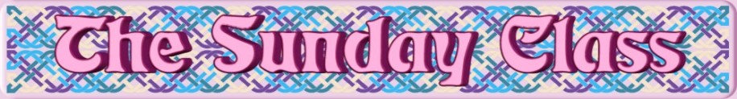

Sunday 24th September 2017 at Castle Bytham Village Hall
4.30pm - 7.30pm

New Year Jig (J8x32)

Save the Children (S8x32)

The Sea Otter & the Pallas Cat (R8x32)

Mid Fodderletter (S4x32)

Yorkshire Lasses (J8x32)

Interval – Tea and cakes!

Summer Social (J8x32)

Bohemian Reflections (R8x32)

Six Belles of Bon Accord (S6x32)

The Courtship (R8x40)

Stanford Swing (J8x40)

- - - - - - - - - - - -

www.thesundayclass.org.uk

