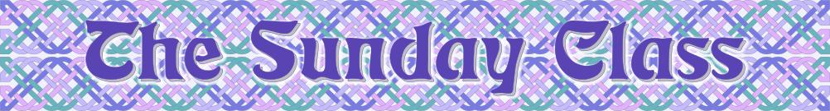
Sunday 26th October 2014 at Castle Bytham Village Hall
Winter time * * * 4.00pm - 7.00pm * * * Winter time

Chased Lovers (J8x32)

High Society (R4x40)

Chasing the Eclipse (S3x32)

The Leather Band (J4x48)

The Paris Celebration Medley (M-5x(S32+R32))

Interval – Tea and cakes!

Emmett’s Chase (J8x32)

Pat’s Strathspey (S5x32)

The Sour Lemon (J8x40)

The Two Gray Cats (R8x40)

www.thesundayclass.org.uk

