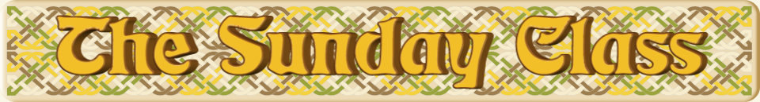

Sunday 22nd May 2016 at Castle Bytham Village Hall
4.30pm - 7.30pm

Ask Miriam (J8x40)

A Musical Page (S8x32)

The Two Inch Race (R5x32)

Loch Snizort Beag (S4x32)

The Anniversary Tensome (R5x32)

Interval – Tea and cakes!

Amanda’s Birthday Dance (S4x40)

The Flitting of Lorn (R4x32)

A Dancer’s Dream (S3x32)

The New York Hornpipe (R8x48)

www.thesundayclass.org.uk

