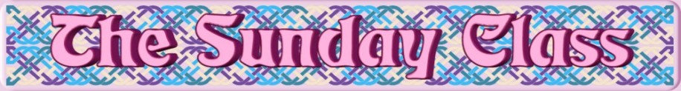

Sunday 20th January 2019 at Castle Bytham Village Hall
4.00pm - 7.00pm

The Hazel Tree (J8x32)

Deer Friends (S8x32)

Ray Milbourne (R4x32)

Far North Queensland (S5x32)

Duddingston Loch (S5x32)

Stanford Swing (J8x40)

Interval – Tea and cakes!

Father Connelly’s Jig (J4x64)

Glengarry Homestead (S4x32)

The Bees of Maggieknockater (J4x32)

The Anniversary Tensome (R5x32)

Torridon Lassies (J8x40)

John of Bon Accord (R8x32)

The Two Gray Cats (R8x40)

- - - - - - - - - - - -

www.thesundayclass.org.uk

