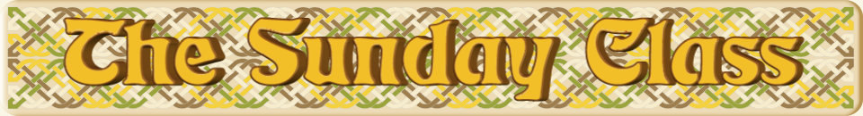

Sunday 10th January 2016 at Eastwell Village Hall
4.00pm - 7.00pm

Includes dances from The Third Sheaf Collection

Swirling & Twirling Leaves (J8x32)

The Potter’s Wheel (R4x32)

Amanda’s Birthday Dance (S4x40)

Failte gu Alba (R8x40)

The Huntsman (J4x40)

Interval – Tea and cakes!

Kamo Karousel (J8x32)

The Grey Wanderer (S4x48)

Nick the Trumpet (R8x40)

- - - - - - - - - - - -

www.thesundayclass.org.uk

