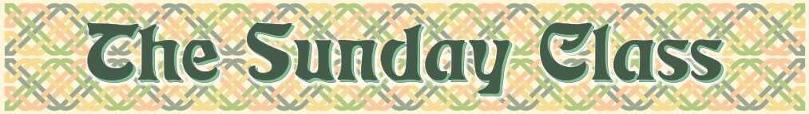
Sunday 3rd February 2013 at Eaton Village Hall
4.00pm - 7.00pm

There is no need to "prepare" for a class
All the dances will be walked through

The White Rabbit 2 (R8x32)

Cherrybank Gardens (S3x32)

Father Connelly’s Jig (J4x64)

John of Bon Accord (R8x32)

Land of the Heather Hills (S4x32)

The Recumbent Stone (R5x48)

Interval – Tea and cakes!

The Craven Twelvesome – 4 men & 8 ladies - (R4x32)

Rannoch Moor (S5x32)

Torridon Lassies (J8x40)

Lady Sophia Lindsay (R4x32)-2chds

Bonnie Stronshiray (S8x32)

_ _ _ _ _ _ _ _ _ _ _ _ _ _

www.thesundayclass.org.uk

