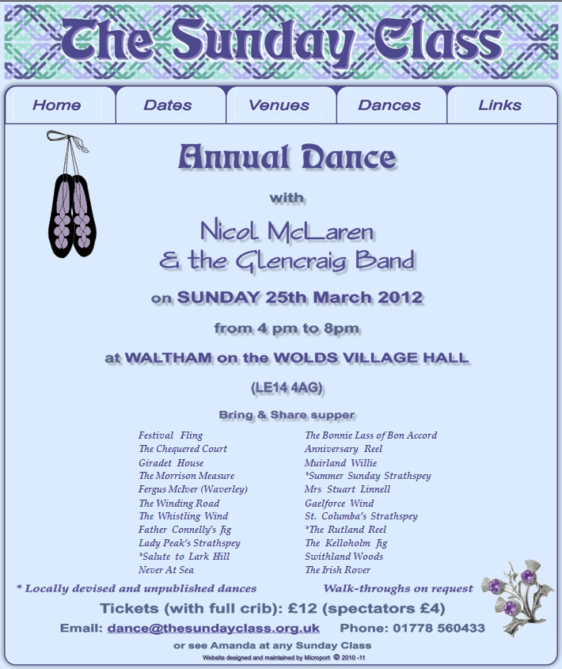
For more information please visit the website: www.thesundayclass.org.uk

