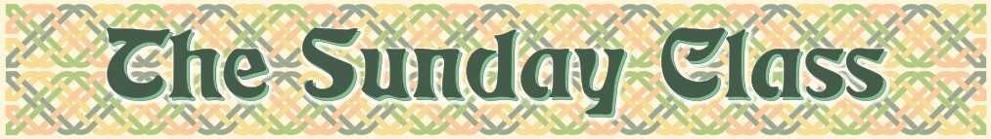

Sunday 5^{h} August 2012 at Castle Bytham Village Hall
4.30pm - 7.30pm

There is no need to "prepare" for a class
All the dances will be walked through

The Dalston Jig (J8x32)

Silver Roses (M-(2xS40)+(2xR40))

George’s Bees (J4x32)

Never At Sea (R6x48)

Land of the Heather Hills (S4x32)

Welcome to Dufftown (J8x32)

Interval – Tea and cakes!

Two Black Cats (R4x32)

The Waltham Ladies (J1x128)

Fireworks (J8x40)

Tribute to Amanda (R8x32)

www.thesundayclass.org.uk

