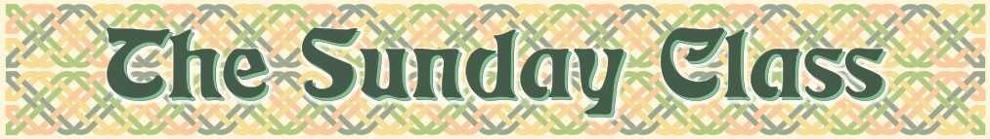
Sunday 18th November 2012 at Castle Bytham Village Hall
4.00pm - 7.00pm

There is no need to "prepare" for a class
All the dances will be walked through

The Hunting Horn (J8x32)

La Ronde (S3x32)

The Hazel Tree (J8x32)

Nottingham Lace (R1x96)

Kilkenny Castle (S8x32)

Andrew’s Dance (R8x32)

Interval – Tea and cakes!

Father Connelly’s Jig (J4x64)

The Garry Strathspey (S4x32)

Tribute to Amanda (R8x32)

Mrs Stuart Linnell (R8x40)

Swiss Lassie (R8x32)

Citty of Belfast (S3x32)

_ _ _ _ _ _ _ _ _ _ _ _ _ _

www.thesundayclass.org.uk

