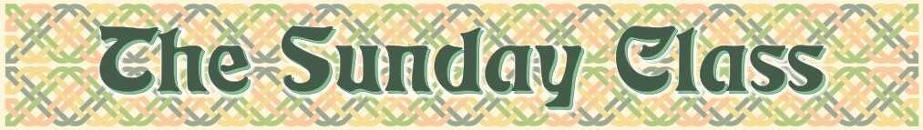
Sunday 16th December 2012 at Eaton Village Hall
3.00pm - 6.00pm

Blooms of Bon Accord (R4x32)

City of Belfast (S3x32)

Father Connelly’s Jig (J4x64)

The Kelpie of Loch Coruisk (R7x32)

The Saltire Medley - 6 people - (M–(S48+R48))

Leaving Lunga (S4x32)

A Reel for Alice (R5x32)

Interval – Tea and cakes!

The Glengarry Homestead (S4x32)

George’s Bees (R4x32)

Anne Duchess of Waltham (S1x80)

Never At Sea (R6x48)

… And the Ladies Wore Red (R4x32)

Iona Cross – 6cpls – (M-(S3x32)+(R3x32))

www.thesundayclass.org.uk

