

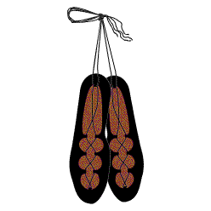
Annual Dance
with
Marian Anderson & her Band

on SUNDAY 17th March 2013

from 4 pm to 8pm

at WALTHAM-ON-THE-WOLDS VILLAGE HALL
(LE14 4AG)

Bring & Share Supper

Shiftin’ Bobbins *Anne, Duchess of Waltham
The Kelloholm Jig The Chequered Court
The Flower o’ the Quern Never At Sea
*The Hard Drive Barbara’s Strathspey
Midnight Oil Father Connelly’s Jig
Giradet House Burnieboozle
*The Rutland Reel City of Belfast
Torridon Lassies Ian Powrie’s Farewell to Auchterarder
*Mrs Millar’s Strathspey Ramadan-ce
A Reel for Alice Glengarry Homestead
Elephant’s Stampede The Irish Rover

* Locally devised dances from the forthcoming TSC Dance Book & CD

Walk-throughs on request

Tickets (with full crib): £13 (spectators £5)

Email: dance@thesundayclass.org.uk Phone: 01778 560433
or see Amanda at any Sunday Class

