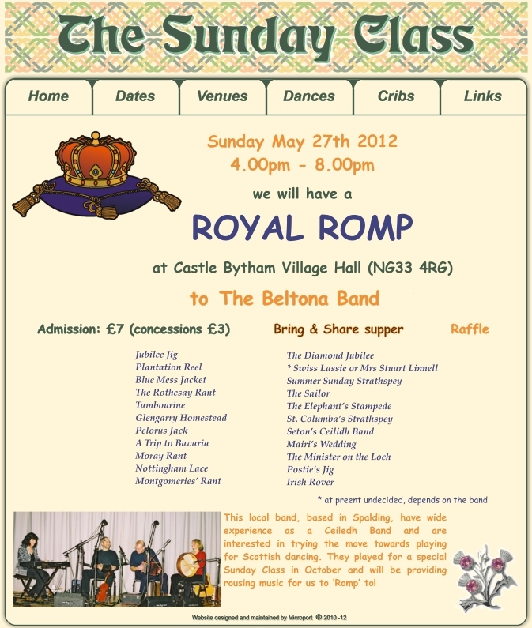

Website: www.thesundayclass.org.uk

Email: amanda@thesundayclass.org.uk

The Sunday Class Royal Romp

on Sunday 27th May 2012 4.00pm – 8.00pm
at Castle Bytham Village Hall (NG33 4RG)

to live music by The Beltona Band

THE JUBILEE JIG (J8x32) SCD Leaflet 19

1- 8 1M casts to 2nd place, sets to 3L, turns RH & dances back to 2nd place on own side
9-16 1L casts to 2nd place, sets to 3M, turns LH & dances back to 2nd place
17-24 1L with 2s & 1M with 3s dance RH across, 1s end in centre LH joined, 1s set in centre & dance out to 2nd place on opposite sides
25-32 1M with 2s & 1L with 3s dance RH across, 1s end in centre LH joined, 1s set in centre & dance out to 2nd place on own sides

PLANTATION REEL (R5x32) Tony Moretti Pinewoods Collection II

1- 8 1s & 3s cross RH & cast down 1 place, lead down between the couple below & cast back to 2nd/4th place (opposite sides)
9-16 2s+1s & 4s+3s dance ½ R&L, & Petronella 2 places anti-clockwise round square (end in same places as at bar 8)
17-24 All dance RH across (1M with 2s, 1L+3M with 4s, 3L with 5s) & 1s & 3s change places with partners to dance LH across
25-32 1s & 3s cross RH cast down 1 place & all turn RH

THE BLUE MESS JACKET (S4x32) Douglas Henderson Kinclaven Book

1- 8 2s followed by 1s lead down the middle, 1s cross & cast up to top & turn in to face 2s who have danced back to place
9-16 1s dance ½ reel of 4 with 2s & ½ turn partner RH to face 3s, 1s dance ½ reel of 4 with 3s & ½ turn partner RH to face 4s
17-24 1s dance ½ reel of 4 with 4s & ½ turn RH, continue turn to end in 4th place opposite sides & all set
25-32 All Petronella to centre & set, Petronella to own sides & set

ROTHESAY RANT (J4x32) Sq.Set Anna Holden SCDs

1- 8 All ½ turn partners RH retain hold & give LH to next person, all set (M facing out), ½ turn next person LH, all set & Ladies turn in
9-16 1s+3s (in 2nd & 4th places) dance ½ Ladies Chain & ½ R&L
17-24 2s+4s dance ½ Ladies Chain & ½ R&L
25-32 All circle 8H round & back

TAMBOURINE (R8x32) Lawrie Bowlen East Ivanhoe Book

1- 8 1s lead down the middle & back to 2nd place own side
9-16 1s dance ½ reels of 3 across (Lady with 2s & Man with 3s) & ½ reels of 3 on opposite sides
17-24 1s dance ½ reels of 3 across (Man up Lady down) & ½ reels on own sides
25-32 2s+1s+3s circle 6H round & back

GLENGARRY HOMESTEAD (S4x32) John Brenchley Kangaroo Paw

1- 8 1s+3s dance ½ Figs of 8 round 2s/4s, 1s+3s dance down 1 place & turn inwards face up as 2s+4s dance up 1 place & in to face 1s/3s, all set
9-16 2s+1s also 4s+3s circle 4H round to left & end on sides, all dance ½ RSh reels of 4 on sides, finishing with 1M & 4M turning 4L & 1L ladies with LH into …. (3)4(1)2
17-24 1s+4s dance the Targe:-
`17-18 1st & 4th Ladies ¾ turn RH while Men dance ¼ way round anticlockwise
`19-20 1st Man with 4th Lady & 1st Lady with 4th Man full turn LH
`21-22 1st & 4th Ladies ¾ turn RH while Men dance ¼ way round anticlockwise
`23-24 1st Man with 4th Lady & 1st Lady with 4th Man turn LH to end on sides to end (3) 1 (4) 2
25-32 All dance ½ RSh reels of 4 on sides, all set & 3s+4s cross to own sides 2 4 1 3

PELORUS JACK (J8x32) Barry Skelton RSCDS Book 41

1- 8 1s cross RH, cast 1 place & dance RH across with 3s, 1s end with Man facing his 1st corner with his partner behind him
9-16 1s dance Alternating Tandem ½ reel of 3 with 1st corners & Alternating Tandem ½ reel with 2nd corners
17-24 1s dance Alternating Tandem ½ reels of 3 with Ladies 1st corner (position) & then with Ladies 2nd corner (position)
25-32 1M followed by partner dance into LH across with 2s, 1s retain LH & ½ turn to own sides, 2s+1s+3s set

A TRIP TO BAVARIA (R4x32) James MacGregor-Brown Collins Pocket Ref

1- 4 1s & 4s cross RH while 2s+3s dance ½ RH across, 1s+3s & 2s+4s change places LH on sides
5-16 3s & 2s cross RH while 1s+4s dance ½ RH across, & repeat until back in original places
17-24 1s set to 2s, cross over to face 3s, set & cross to face 4s
25-32 1s set to 4s & cross over to 4th place on opposite sides, all Adv+Ret 2 steps 1s changing places 2H to retire to own sides

MORAY RANT (S3x48) John Drewry Silver City Book

1-8 1s dance Inveran Reels with 2s+3s & end with 1s crossing RH to opposite sides
9-16 1s set advancing & turn 2H, lead down & dance out between 2s & 3s, cast behind 3s & turn into face 3s
17-24 1s set & turn 3s (1s dancing out at sides), lead up between 3s, dance out between 2s & 3s, cast up behind 2s & turn into face 2s
25-32 1s set & turn 2s (1s dancing out at sides) into 1st place opposite sides & dance ½ fig of 8 round 2s back to 1st place on own sides
33-40 1s+2s circle 4H once round to Left, 1s facing 2s set & 1s cast to 2nd place as 2s lead up to 1st place
41-48 1s+3s circle 4H once round to Left, 1s facing 3s set & 1s cast to 3rd place as 3s lead up to 2nd place

NOTTINGHAM LACE (R96) Sq.Set Jenny Bradley Nottingham Lace

PART 1
1- 8 All dance ½ Chain & set to partners, ¾ turn RH to end with Ladies in centre
9-12 Ladies dance LH across ½ way while Men dance ¼ way round clockwise, Ladies ½ turn nearest Man RH
13-16 Men dance LH across ½ way while Ladies dance ¼ way round clockwise & all turn partners RH
17-24 All repeat bars 9-16 to original places

PART 2
25-32 1L & 3M change places RH, cast behind 4s & change places RH to join end of line while 1M & 3L dance similarly behind 2s, all set
33-40 All Adv+Ret, 1s+2L+4M also 3s+2M+4L circle 4H round to left to end in line across (1s & 3s in centre of line)
41-48 All Adv+Ret, circle 8H round ½ way to end in Sq.Set opposite to original places

PART 3
49-72 Repeat PART 2 with 2s & 4s as dancing couples, all ending in original places

PART 4
73-96 Repeat PART 1

THE MONTGOMERIES' RANT (R8x32) Castle Menzies RSCDS Book 10

1- 8 1s cross RH & cast down to 2nd place, cross LH & 1L casts up while 1M casts down
9-16 1s dance reels of 3 across, 1L with 2s & 1M with 3s
17-24 1s with nearer hands joined (Lady on Mans left) set to 2L, turn inwards & set to 3M, set to 3L, turn in & set to 2M
25-32 2s+1s+3s dance reels of 3 on opposite sides 1s giving RSh to 2nd corner, 1s cross RH to 2nd place own sides

.oOo. INTERVAL .oOo.

THE DIAMOND JUBILEE (J4x32) Robert M Campbell RSCDS Book 31

1- 8 1s & 4s turn 1½ times RH & cast 1 place, 1M & 4M also 1L & 4L turn LH on sides to end 1s facing up & 4s down. 2(1)4(3)
9-16 All dance reels of 4 on sides (1s & 4s do not fully complete reel but turn right about to BtoB in centre facing corners)
17-24 4s & 1s set to corners & change places RH, set & change back LH
25-32 1s+4s dance RH across while 2s & 3s set & cross RH, all set & cross RH back to places

SWISS LASSIE (R8x32) Rosi Betsche RSCDS Book 39

1- 8 1s dance in & cast to 3rd place, 2s+1s turn partners RH 1¼ times to form a line up & down middle of set (Men facing down Ladies up)
9-16 2s+1s dance reel of 4 up & down middle of set ending with 2M facing Ladies’ side & 1L facing Men’s side
17-24 2s+1s chase round clockwise ½ way, 1s+3s+2s Advance+Retire
25-32 3s+2s ½ turn partners RH, dance ½ RH across, 1s+2s ½ turn partners RH & dance ½ RH across

OR

MRS STUART LINNELL (R8x40) John Bayly

1- 8 1s set & cast 1 place, 2s+1s+3s set and then 2M & 3L cast into 2nd places while 1s set adv & turn right about to face them (1M facing 2M & 1L facing 3L in a line across) while 2L & 3M petronella right to face each other on the centre line (2L at top, 3M at bottom)
9-12 1s+2M+3L ½ reel of 4 across
13-16 1s ¾ turn LH to Lady facing up & Man down (M face M, L face L) on the centre line, 1s change places RH with facing persons (2L & 3M)
17-20 2L+3M+1s ½ reel of 4
21-24 2L+3M ¾ turn LH to face opposite sides (M facing M, L facing L) in line across, 3L+2L, 3M+2M change place RH with facing persons
25-28 2L+3L, 2M+3M dance ½ reel of 4 across
29-32 All set (3M facing 2M, 3L facing 2L in line across in 2nd place, 1s facing up & down on centre line), 2M+3M & 2L+3L ¾ turn RH onto sides while 1s set & turn right about on spot to form a circle with 1s+2s+3s all facing clockwise
33-36 All chase clockwise halfway
37-40 2s+3s continue to chase (3M & 2L holding back) while 1s turn RH 1¼ in centre to end on own sides 2 1 3

SUMMER SUNDAY STRATHSPEY (S4x32) Sq. set Amanda Peart

1- 8 All set, advance and individually pivot to right, dance on one place (¼ anti-clockwise), petronella turn out to sides
9-16 Interlocking R&Ls:
2s face 4s (new end couples) whilst 1s & 3s (on sides) face partner and all dance standard R&Ls within those couples and finish facing corners
17-24 All set, turn corners 2H (once or twice in 4 bars), all set, joining hands in circle
25-32 All circle 8H round & back

THE SAILOR (R8x32) RSCDS Book 24

1- 8 1s cross down RH to face out between 2s & 3s giving hands to each corner & set, 1s cast round 1st corner to form lines of 3 across with 2s/3s & 2s+1s+3s set
9-16 1s (turning to right) dance RSh reels of 3 across, 1s end passing LSh to 2nd place on opposite sides
17-24 1s lead down for 2 bars, lead up crossing to the top & casting to 2nd place on own sides
25-32 2s+1s dance R&L

THE ELEPHANT’S STAMPEDE (J4x48) Sq.Set
Lorna MacDonald+Gillian Mackintosh Aurora 10th Anniversary Book

1- 8 All circle 8H round & back
9-16 1s+3s advance & with free hand join with 2s & 4s & retire into longwise set across the dance, all dance ½ parallel reels of 4 across
17-24 All dance ½ R&L at each end of set, turn (person on Man’s left) RH 1½ times to form square set
25-32 All Ladies petronella turn to next Ladies place to right & set, repeat to meet partner (all have progressed 1 place to right)
33-48 All dance full Schiehallion Reel

ST COLUMBA'S STRATHSPEY (S5x32) Vicky Sproule & Sadie Gillan

1- 8 2s & 4s dance RH across, 2s dance up while 4s dance down, 2s & 4s casting round ends on own sides to face 1st corners
9-16 2s & 4s dance Pass & Turn with corners (dancing couples pass LSh in centre) & end in line in centre facing partner (Men up & Ladies down)
17-24 2s & 4s dance reel of 4 ending in original places on sides
25-32 2s & 4s set & cast down 1 place while 3s & 5s set & dance up 1 place, 1s & 2s turn RH & cast down 1 place 3 1 5 2 4

SETON'S CEILIDH BAND (J4x64) A Bruce Fordyce Morison's Bush Collection

1- 8 1s cross RH & cast 1 place, lead down between 3s & cast behind 4s
9-16 1s dance reflection reels of 3 on opposite sides beginning by dancing up between 4s
17-24 1s cross RH & cast up 1 place, lead up between 3s & cast up behind 2s
25-32 1s dance reels of 3 on own sides beginning by dancing down between 2s
33-40 1s cross RH & cast down 1 place to give RH to partner & LH to 1st corners, Balance-in-Line, turn partner RH to give LH to 2nd corners
41-48 Balance-in-Line, 1s dance out & cast down behind 3s & lead up to top crossing to 1st place own sides
49-60 1L+2L & 1M+2M change places RH on sides, 2s & 1s cross over LH & repeat with 3s & 4s until reaching the bottom of the set
61-64 All turn RH 1½ times

MAIRI'S WEDDING (R8x40) James B Cosh 22 SCDs+2

1- 8 1s turn RH, cast to 2nd place & turn LH to face 1st corners
9-16 1s dance ½ diagonal reel of 4 with 1st corners & ½ diagonal reel with 2nd corners
17-24 1s dance ½ diagonal reel with 3rd corner (position) & ½ diagonal reel with 4th corner (position)
25-32 1s dance reel of 3 across (Lady with 2s, Man with 3s - LSh to 1st corner)
33-40 2s+1s+3s circle 6H round & back

THE MINISTER ON THE LOCH (S3x32) Roy Goldring 24 G&S Dances

1- 8 1s+2s dance Diamond Poussette right round
9-16 1s dance down for 2 steps, turn 2H, dance up to top & turn 2H
17-24 1s+3s dance double Fig of 8 round 2s with 1s casting to start
25-32 1M+2M turn LH 1½ times whilst 1L+2L turn RH 1½ times, 1M+3M turn RH 1½ times whilst 1L+3L turn LH 1½ times

POSTIE'S JIG (J4x32) Roy Clowes Ormskirk 5

1- 8 1s & 4s set, cast in 1 place & dance ½ Figs of 8 round new end couples
9-12 1M+4M & 1L+4L dance across (men making an arch), turn corners with free hand to face up/down
13-16 1s+4s dance down/up (couple dancing up make the arch) & turn corners
17-24 Repeat bars 9-16 from new positions
25-32 1s+4s dance ½ R&L & turn partner RH

THE IRISH ROVER (R8x32) James B Cosh 22 SCDs+1

1- 4 1s dance down below 3s & cast up to 2nd place own sides
5- 8 1L dances RH across with 2s while 1M dances RH across with 3s
9-16 1s dance ½ diagonal reel of 4 with 1st corners then ½ reel with 2nd corners & ½ turn LH in centre to face 1st corners
17-24 1s dance reels of 3 across giving LSh to 1st corners ending in 2nd place own sides
25-32 1s dance Diag R&L (1M crossing down & 1L crossing up to start)

