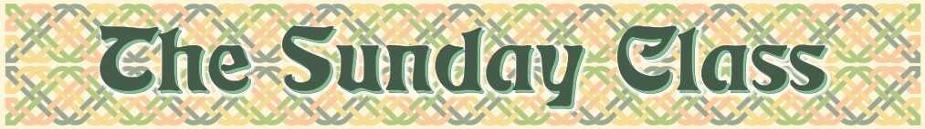
Sunday 2nd September 2012 at Eaton Village Hall
4.30pm - 7.30pm

There is no need to "prepare" for a class
All the dances will be walked through

George’s Bees (R4x32)

Mrs Millar’s Strathspey (S4x32)

Rachan Mill (J4x32)

Barbara’s Strathspey (S8x32)

Lacing o’ the Ghillies (R5x40)

Interval – Tea and cakes!

The Saltire Medley - 6 people - (M–(S48+R48))

Reel of the Puffins (R4x32)

Best Set in the Hall (J8x32)

Kinfauns Castle (S5x32)

History in the Making (R3x32)

www.thesundayclass.org.uk

