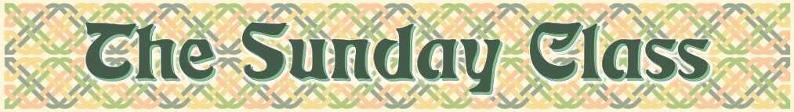
Sunday 4th November 2012 at Eaton Village Hall
4.00pm - 7.00pm

There is no need to "prepare" for a class
All the dances will be walked through

Sparks Fly (J8x32)

Andrew’s Dance (R8x32)

Summer Sunday Strathspey (S4x32)

Best Set in the Hall (J8x32)

Mrs Stuart Linnell (R8x40)

Interval – Tea and cakes!

Fireworks (J8x40)

The Saltire Medley - 6 people - (M–(S48+R48))

Kinfauns Castle (S5x32)

The Wooden Horse (J3x32)

The Fireworks Reel (R8x32)

_ _ _ _ _ _ _ _ _ _ _ _ _ _

www.thesundayclass.org.uk

