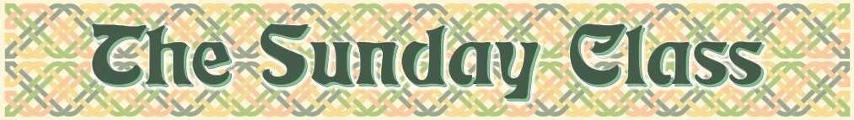
Sunday 7th April 2013 at Eaton Village Hall
4.30pm - 7.30pm

There is no need to "prepare" for a class - all the dances will be walked through

Loch Leven Castle (R6x32)

James Senior of St. Andrews (S4x32)

The Merry Dancers (J8x32)

Glayva (R8x32)

The Cashmere Shawl (S8x32)

The Ambassadors’ Reel (R8x32)

Interval – Tea and cakes!

The Castle of Mey (R8x32)

Seven to Seven (S3x32)

Hungarian Bride (R5x48) Sq.set

The Bramble Bush (J8x32)

The Munro Rant (S6x32)

The Bell Rock Reel (R8x40)

www.thesundayclass.org.uk

