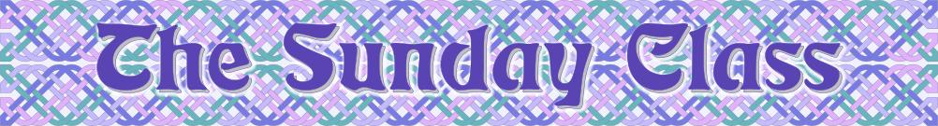
Sunday 1st June 2014 at Castle Bytham Village Hall
4.30pm - 7.30pm

I have volunteered us to trial dances for inclusion in a 10th Anniversary Book for the RSCDS International Branch (of which I am a member). We have a batch of 8 dances, 3 of which I have included in this week’s programme, and there will be no crib issued for these dances

Dance 42 (J8x32)

Dance 43 (S8x32)

MacVicar’s Hornpipe (R8x32)

Torridon Cross (J4x48)

1314 (M-(S64+R64))

Interval – Tea and cakes!

Dance 45 (R8x32)

Festival Dream (S1x64)

Sunshine in Lagos (J8x32)

Eilean Donan Castle (S3x48)

High Society (R4x40)

www.thesundayclass.org.uk

