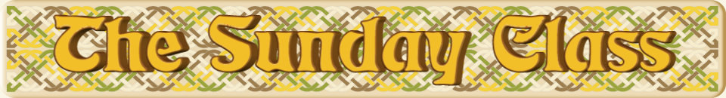

Sunday 30th October 2016 at Castle Bytham Village Hall
4.00pm - 7.00pm

The Bees They Are a’Drummin’ (R8x32)

Festival Dream (S1x64)

The Tipsy Vicar (J8x32)

The Night Owl (S4x40) – Robert Senior

Merry St. Andrews (J8x40)

Interval – Tea and cakes!

Pat George’s Strathspey (S5x32)

The Courtship (R8x40)

Broadway (S3x32)

Staircase in Styria (R5x40)

- - - - - - - - - - - -

www.thesundayclass.org.uk

