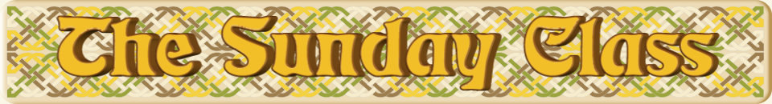

Sunday 20th November 2016 at Castle Bytham Village Hall
4.00pm - 7.00pm

Torridon Lassies (J8x40)

Strathcare (S8x32)

The Courtship (R8x40)

Mrs Millar’s Strathspey (S4x32)

Staircase in Styria (R5x40)

Interval – Tea and cakes!

Broadway (S3x32)

Lady in Red (J5x32)

The Silver Grey (S3x32)

The Two Gray Cats (R8x40)

- - - - - - - - - - - -

www.thesundayclass.org.uk

