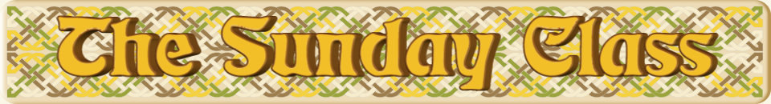

Sunday 28th June 2015 at Castle Bytham Village Hall
4.30pm - 7.30pm

The Cooper Children (J8x40)

Candyfloss (S3x32)

Jovial Jack (R8x32)

Scarborough Castle (S8x32)

The Huntsman (J4x40)

Interval – Tea and cakes!

Barry & Doreen’s Continental Capers (R4x32)
or
Raising the Anchor (R5x32)

The Blue Lights of Pizza Express (S4x32)

The Globe Inn (J8x32)
or
Kentish Ruby (J4x40)

Ardgilzean (S4x32) 2chds
or
Far North Queensland (S5x32)

The Cuckoo Clock (R8x32)

www.thesundayclass.org.uk

