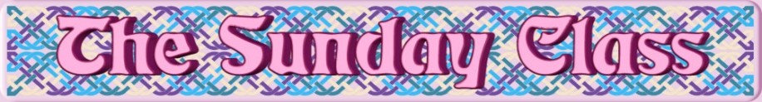

Sunday 16th July 2017 at Castle Bytham Village Hall
4.30pm - 7.30pm

The Fentham Jig (J8x32)

Celebration at Higham (S8x32)

The Sea Otter & the Pallas Cat (R8x32)

The Orchards of County Armagh (S3x32)

Doodling At Dawn (J4x32)

Interval – Tea and cakes!

The River Ness (R5x32)

The Bruce That Was (J8x32)

Higham Hogmanay (R8x32)

Brecon in March (R5x40)

Stanford Swing (J8x40)

- - - - - - - - - - - -

www.thesundayclass.org.uk

