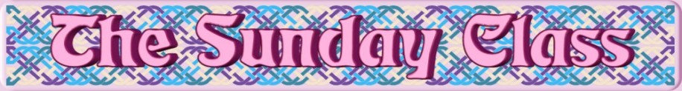

Sunday 3rd September 2017 at Eastwell Village Hall
4.30pm - 7.30pm

RSCDS Book 51

Fair Enough (J4x32)
The Somerset Children’s Reel (R8x32)
Save the Children (S8x32)
The Edinburgh Toy Shop (J8x32)
Summer on the Beach (R4x32)
And for the Young Ones (J4x32)

Interval – Tea and cakes!

New Year Jig (J8x32)
Holyrood Strathspey (S8x32)
Pluto’s Head (R8x32) 2cpl
Hello-Goodbye (S8x32)
Come What May (J8x32) 2cpl
Bohemian Reflections (R8x32)

Figure It Out (R3x32) – CD116.12

A Reel for Alice (R5x32) – CD245.1

- - - - - - - - - - - -

www.thesundayclass.org.uk

