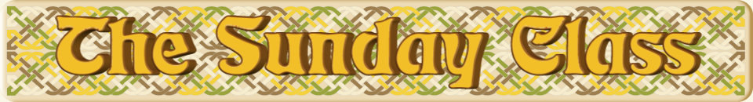

Sunday 12th April 2015 at Eaton Village Hall
4.30pm - 7.30pm

The Bees They Are a’Drumming (R8x32)

Tiaras & Teapots (J8x40)

Calm Before Storm or The Musical Page (S8x32)

The Courtship (R8x40)

Marja’s Buns (M-(S48+R48)) 6 cpls – Sunday Tea

Interval – Tea and cakes!

The Tipsy Vicar (J8x32)

The Gypsy Weaver (S8x32)

Jan Maree (R3x32)

Water of Leith (S4x32)

Bristol’s Welcome (R4x40)

- - - - - - - - - - - -

www.thesundayclass.org.uk

