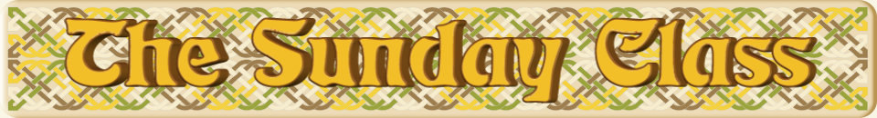

Sunday 26th July 2015 at Castle Bytham Village Hall
4.30pm - 7.30pm

Yan Tan Tethera (J8x32)

Golden Hind (S8x32) or (S3x32)

Whippety Stourie (R8x32)

Rannoch Moor (S5x32)
or
The Swan & the Tay (S3x32)

The Huntsman (J4x40)

Interval – Tea and cakes!

Tiaras & Teapots (J8x40)

A Dancer’s Dream (S3x32)

Ask Miriam (J8x40)

This One’s Four Isobel (S4x32)

The Recumbent Stone (R5x48)
or
Fire in the Rye (R6x32)

www.thesundayclass.org.uk

