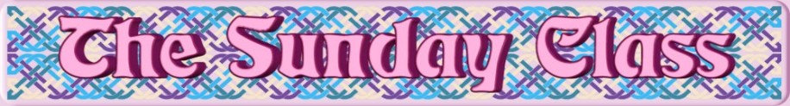

Sunday 29th September 2019 at Castle Bytham Village Hall
4.30pm - 7.30pm

Lack o’ Men (R4x40) 6pl

The Brigs o’ Ayr (S3x32)

Mill Rig (J6x32) 2C

Elegant Cranes Strathspey (S3x32)

Fiona Fair (R6x32) 2C

Interval – Tea and cakes!

Merlin Spike (R8x32)

You Are Not Alone (S3x32)

Paranoid Jig (J8x32)

A Dancer’s Dream (S3x32)

The First Rain of Spring (J3x32)

- - - - - - - - - - - -

www.thesundayclass.org.uk

